Steps to USER Creation

Step 1: Login to sandbox and click on setup and search for Users in Quick find check box.
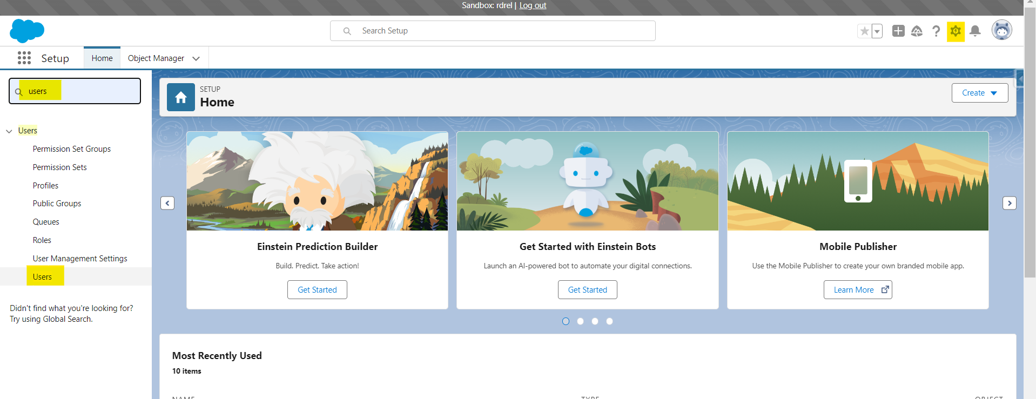

Step 2: Click on New User button to create new User and fill mandatory fields and click on Save.
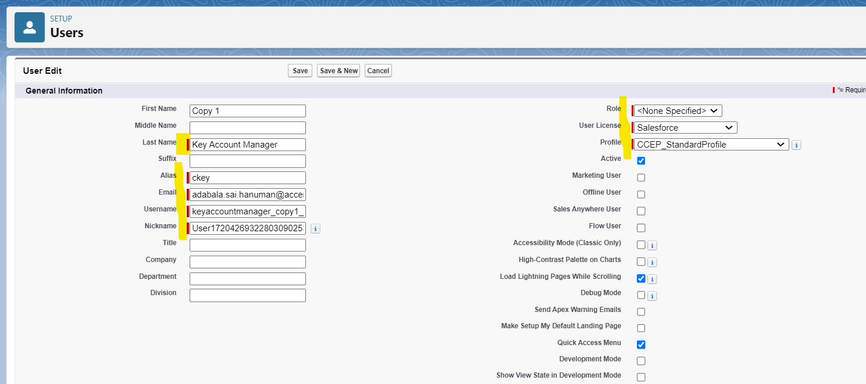
Step3: Add required permission set group by clicking on edit assignment and assign required group and click on save.
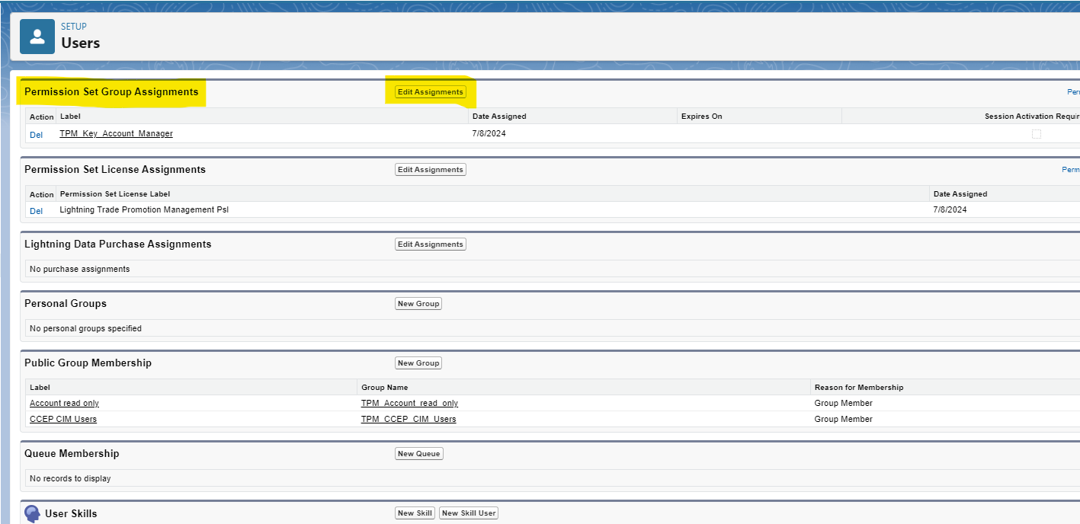
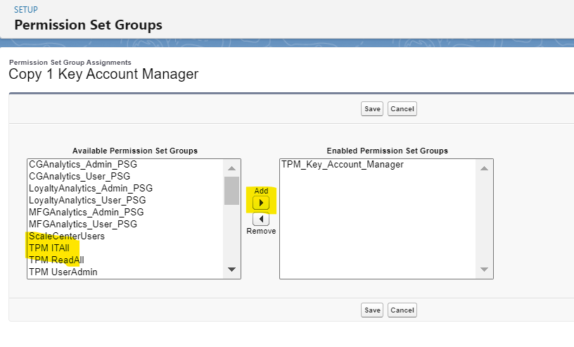
Step 4: Add public groups by clicking on public groups and click on edit for Account read only and
CCEP CIM Users and add required Users to the group and click on save.
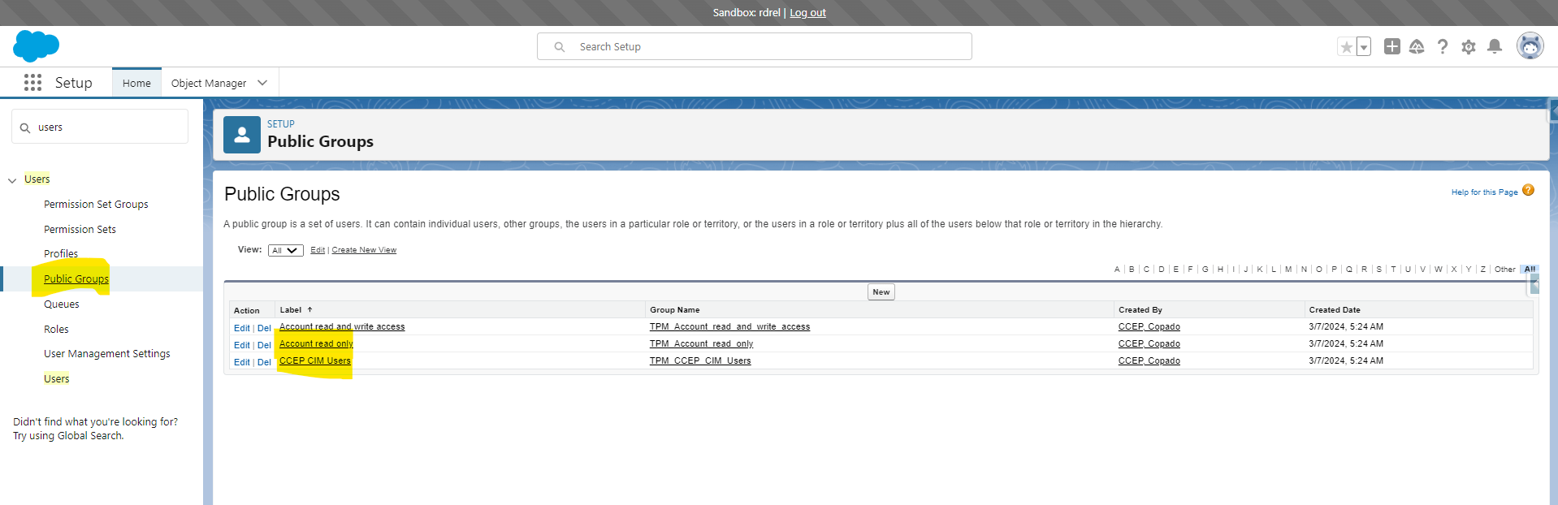
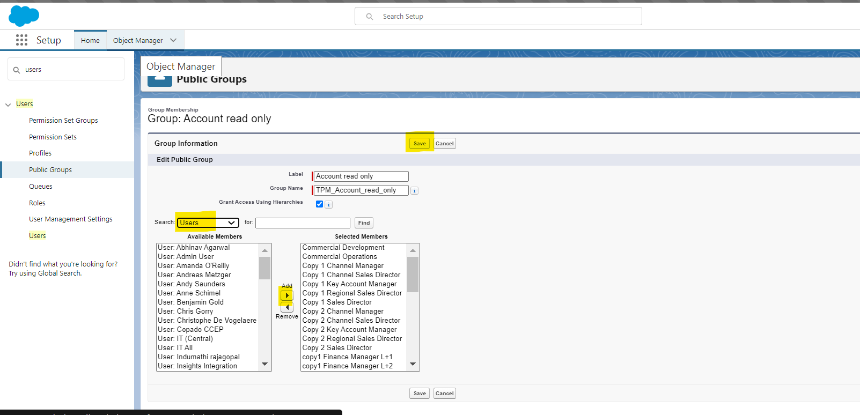

Step 5: To add Queue membership click on Queues and select the queue needs to be added and click on edit to add the user to the queue and click on save
